A **race condition** occurs when a software [program](https://techterms.com/definition/program) depends on the timing of one or more [processes](https://techterms.com/definition/process) to function correctly. It can occur if a [thread](https://techterms.com/definition/thread) runs or finishes at an unexpected time which may cause unpredictable behaviour, such as incorrect output or a program [deadlock](https://techterms.com/definition/deadlock).

1st Example of goroutine:

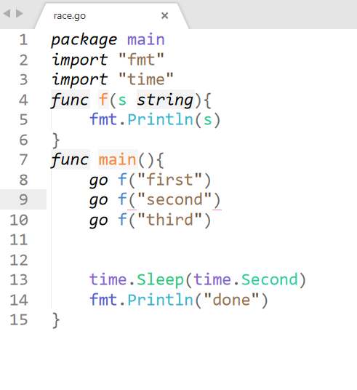

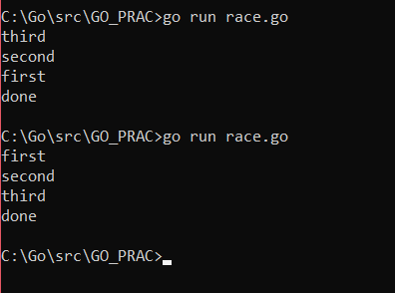

2nd Example of Goroutine:

